Experiment 7: Implement Random Forest and Analyze Performance
Aim
To implement a Random Forest classification algorithm to predict students' results based on Hours_Studied, Attendance, and Assignments, evaluate the model's performance, and visualize the importance of each feature.
Algorithm
- Import the required libraries: Pandas, train_test_split, RandomForestClassifier, evaluation metrics, and Matplotlib.
- Load the dataset from the CSV file data.csv.
- Select the input features Hours_Studied, Attendance, and Assignments and store them in X.
- Select the target variable Result and store it in y.
- Split the dataset into training and testing sets using train_test_split(), with 80% for training and 20% for testing.
- Create a Random Forest classifier using RandomForestClassifier(n_estimators=100, random_state=42).
- Train the model using model.fit(X_train, y_train).
- Predict the results for the testing dataset using model.predict(X_test).
- Evaluate the model using accuracy_score(), confusion_matrix(), and classification_report().
- Extract feature importance values using model.feature_importances_.
- Plot the feature importance values using a bar chart.
- Add axis labels and a title, and display the graph using plt.show().

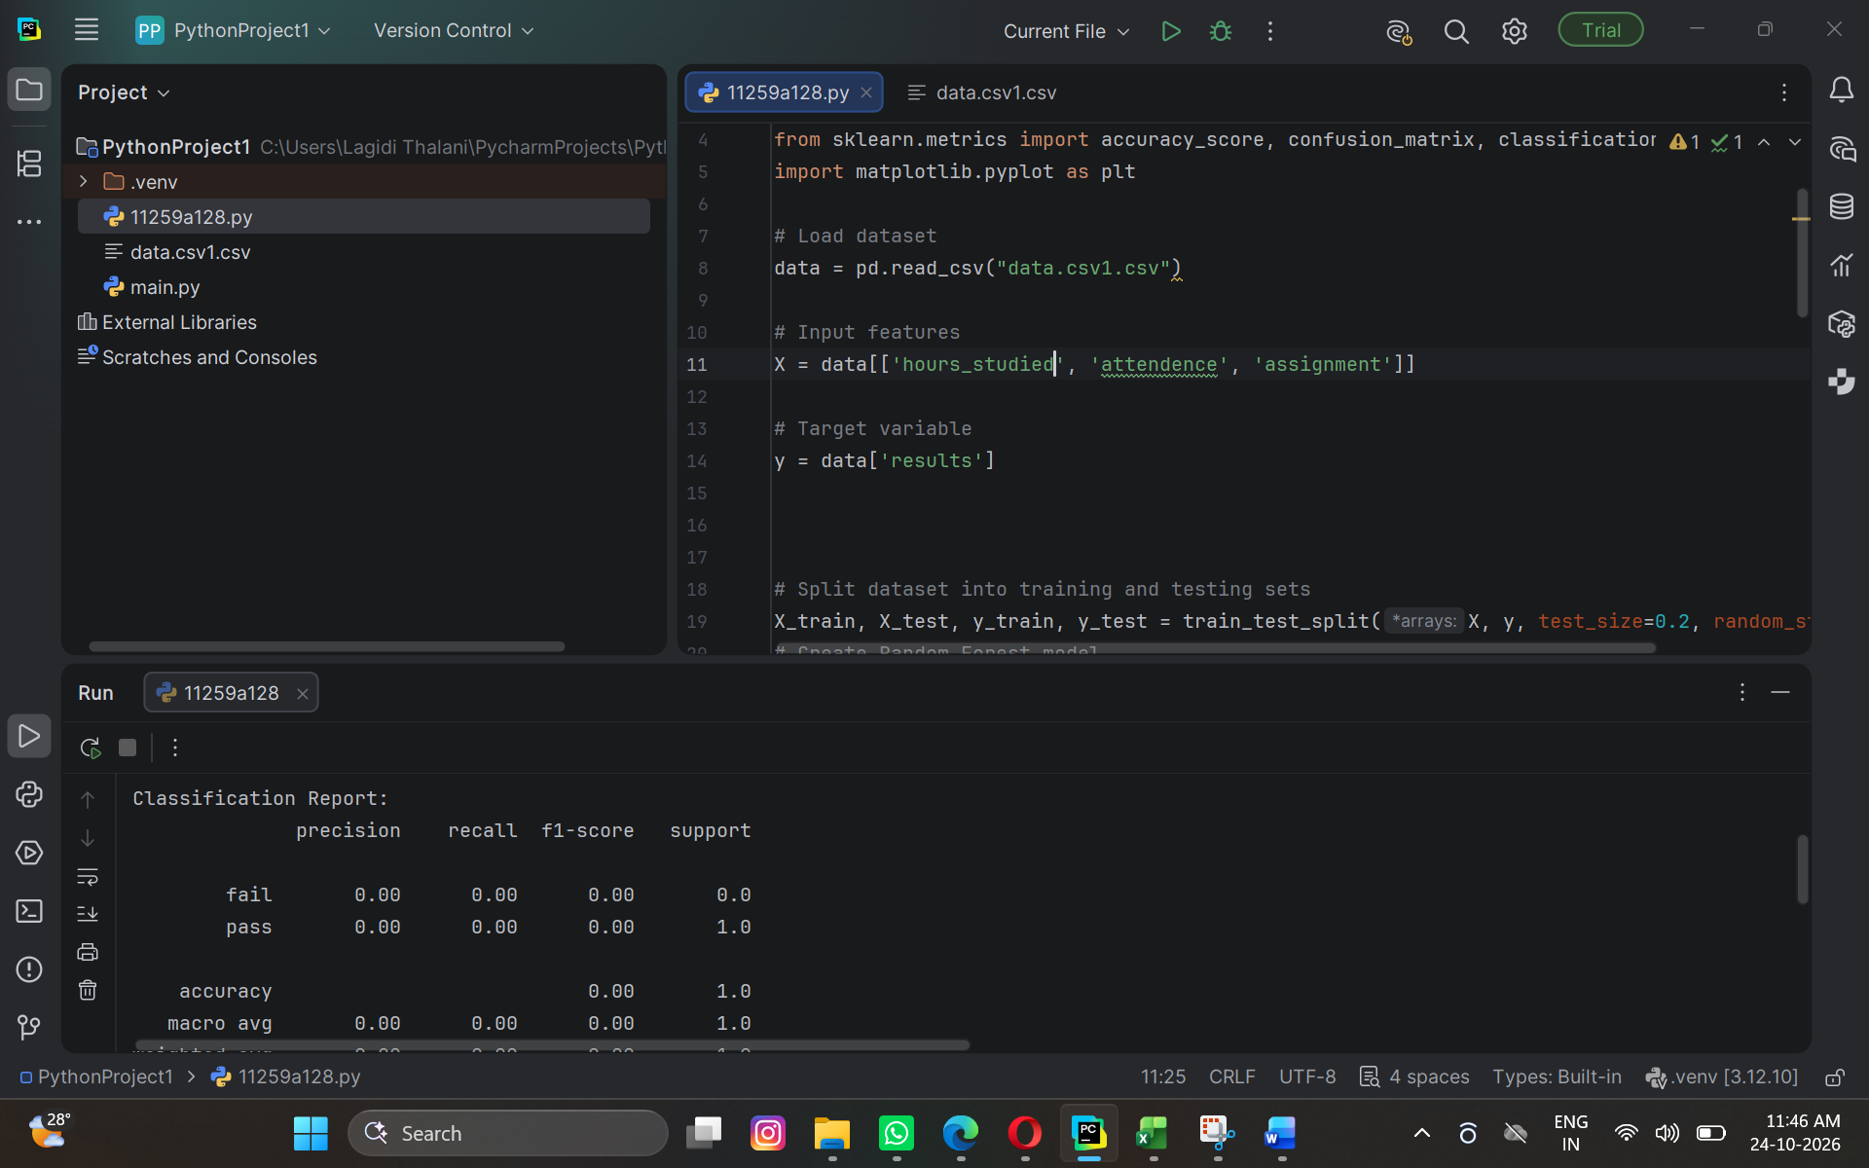

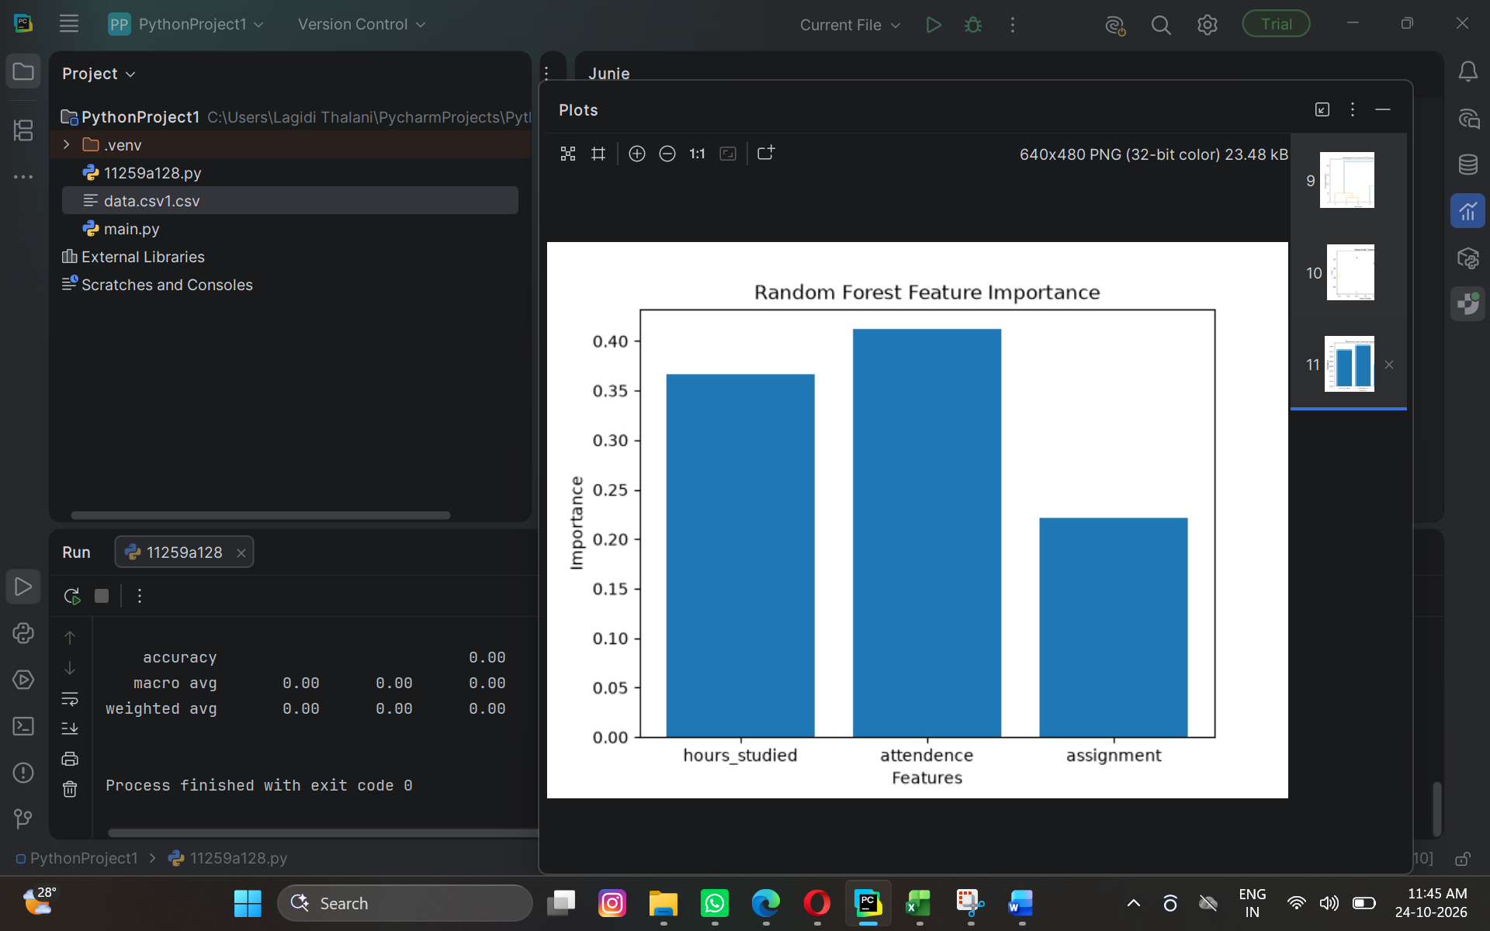

Result
The Random Forest classification model was successfully trained and evaluated. Based on the provided output, the model achieved an accuracy of 95% on the test dataset.

